DAT505
LESSON NOTES 05/11/2018

- Perlin noise
  - Random but with correlation
  - Creates an organic result
  - Terrain generation with Perlin noise
- Mathematical functions such as the sin can be used in three.js
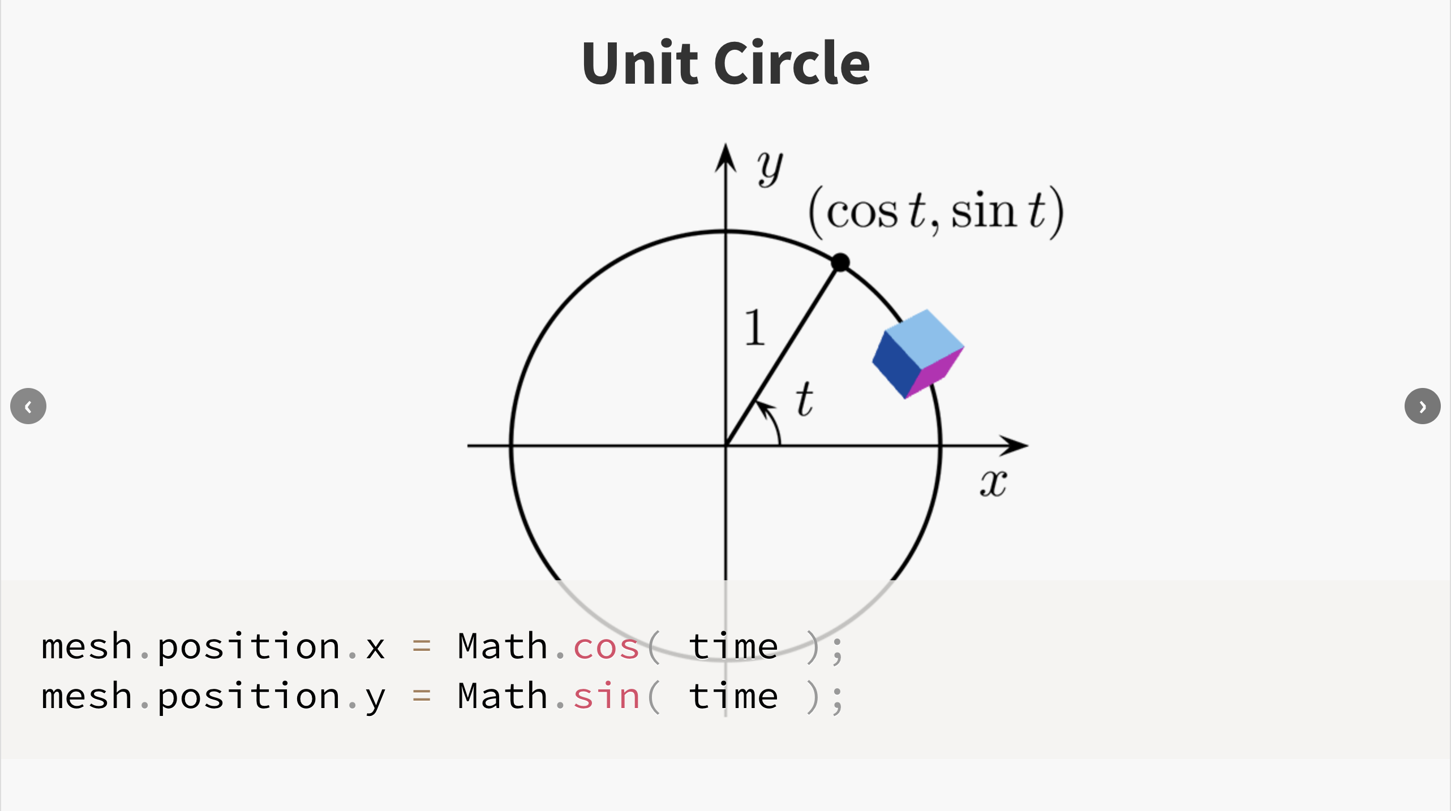
  - Create waves and recurring paths

